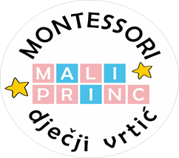

**Montessori Dječji vrtić „Mali Princ“**

Zagrebačka 48, 52000 Pazin

**Mob. Br.(Ingrid Baxa): 091/301-7553**

**Ravnateljica**: Ingrid Baxa

**E-mail**: maliprinc.montessori@gmail.com

**OIB**: 01664737504

KLASA: 034/01/22-01/02

URBROJ: 2163-1-23/01-22/________

**ZAHTJEV ZA NASTAVAK KORIŠTENJA USLUGA MONTESSORI DJEČJEG VRTIĆA „MALI PRINC“**

**za pedagošku 2022./2023. godinu**

Ime i prezime djeteta: ___________________________________

Datum rođenja: _____________________________________

Izmjena osnovnih podataka o djetetu (ukoliko postoji) (adresa prebivališta, popis/kontakt brojevi telefona roditelja/osoba koje dolaze po dijete, promjena pedijatra, izmjena zdravstvenog stanja djeteta (alergije i sl.):

______________________________________________________________________________

______________________________________________________________________________

______________________________________________________________________________

Ukoliko imate dodatnih pitanja slobodno nam se javite na 0913017553 (Ingrid Baxa) ili na email: maliprinc.montessori.gmail.com

Pazin, _______________________

Potpis roditelja/skrbnika:

____________________________